Results and Discussion

## 3.1. Results

**No-choice behavior assays**

The number of probing events observed differed significantly among germplasms (Table 3.2). Psyllids exhibited more probes on Russet Burbank than on 10LB, 3LB, and 4LB (Figure 3.1). The number of probing events did not differ significantly between sexes, nor was the interaction term statistically significant (Table 3.1); however, female psyllids tended to probe Russet Burbank plants more frequently than any other germplasm and sex combination (Figure 3.1). Probing duration did not differ significantly among germplasms, between sexes, or their interaction (Table 3.2).

The incidence of walking events differed significantly among germplasms (Table 3.2); psyllids walked more on Russet Burbank than 10LB or 3LB (Table 3.3). The sex × germplasm interaction term was significant (Table 3.2): Female psyllids walked more frequently on Russet Burbank than 10LB, 3LB and females on 4LB germplasms (Figure 3.3). Males walked significantly more often on 4LB than 10LB (Figure 3.3). Other interactions were not significant. Walking duration did not differ among germplasms or between sexes; however, the interaction term between sex and germplasm was significant (Table 3.2). Female psyllids walked significantly longer on Russet Burbank than psyllids on 10LB, female psyllids on 3LB, or male psyllids on Russet Burbank (Figure 3.4). Walking duration was not significantly different between female psyllids on 10LB, male and female psyllids on 3LB, female psyllids on 4LB or male psyllids on Russet Burbank (Figure 3.4).

Cleaning duration and cleaning events did not significantly differ among germplasms, between sexes, or in their interactions (Table 3.2). Psyllids leaving their leaves were not analyzed due to low occurrences of this behavior (see *'Statistical Analysis').*

**Fecundity assays**

There were significant differences between germplasms. (Hopefully?) (Table 3)

## 3.2. Discussion

Host plant variety has been shown to affect probing and oviposition behaviors in the potato psyllid (Butler et al. 2011, Cooper and Bamberg 2014, Prager et al. 2014, Thinakaran et al. 2015).

Feeding is associated with Lso severity (Rashidi et al. 2017). A single psyllid is sufficient to transmit Lso (Buchman et al. 2011), and transmission can occur in as little as five minutes (Mustafa et al., 2015b). Even so, Lso transmission is not always consistent with the frequency or duration of ???

Our findings of probing incidences were similar to Butler et al. (2011) and Prager et al. (2014a), which noted significant differences in probing events between germplasms.

A possible explanation for higher probing and walking frequency is that phytoplasmas (including Lso) can alter host plant preferences (Mayer et al. 2008) and settling behavior (Mas et al. 2014). Lso-infected psyllids prefer undamaged, uninfected hosts for oviposition and settling (Davis et al. 2012)—a behavior that is seen in other insect-plant-vector relationships (Cao et al. 2016). Our psyllids were all Lso-positive and may have been influenced by plant volatiles specific to Russet Burbank. Patt et al. (2011) demonstrated that the Asian citrus psyllid, *Diaphorina citri* Kuwayama (Hemiptera: Liviidae), increased probing activities in response to visual and volatile cues. Similar sensory studies have shown synergistic effects of visual and volatile cues on host plant attraction in *D. citri* (Davidson et al. 2014, Wenninger et al. 2009).

Although the sex × germplasm interaction was not significant in our study, we did observe a trend of increase probing by female psyllids. Investigations of behavioral differences by sex may help to determine what role sex plays in host selection for *B. cockerelli.* Lso-infected female carrot psyllids have been shown to cause more damage than male psyllids feeding (Nissinen et al. 2013). Zhao et al. (2015) have observed differences in viral transmission based on sex: male western flower thrips transmit more tomato spotted wilt virus than females (Zhao et al. 2015).

Further studies would help to determine how these results correlate with psyllid host acceptance. It is interesting to note that only 20 out of 182 (11%) of observed psyllids left the leaf surface. It may be that the time between the initial encounter, probing/feeding and the eventual rejection of a host may typically be longer than the duration of our behavioral assays. Recording times may also explain the significant differences between walking duration, which contrasted with the results of Butler et al. (2011). We found significant differences between walking events.

However, perhaps the modality of resistance for the A07781 germplasms is mainly tolerance to the Lso, rather than antibiotic/antixenotic interactions with the psyllid vector. Rashed et al. (2012) found that zebra chip progressed independently of bacterial titer and the number of psyllids feeding on the plant. Rashed et. al (2012) also found that the disease incubation time was decreased by the presence of more psyllids and that infection was acquired more easily by psyllids which had access to the whole plant.

**Fecundity**

Prager et. al (2014a) found no association between nymphal development and host-plant selection by female psyllids in pepper, but that psyllid host-plant selection was influenced by their haplotype.





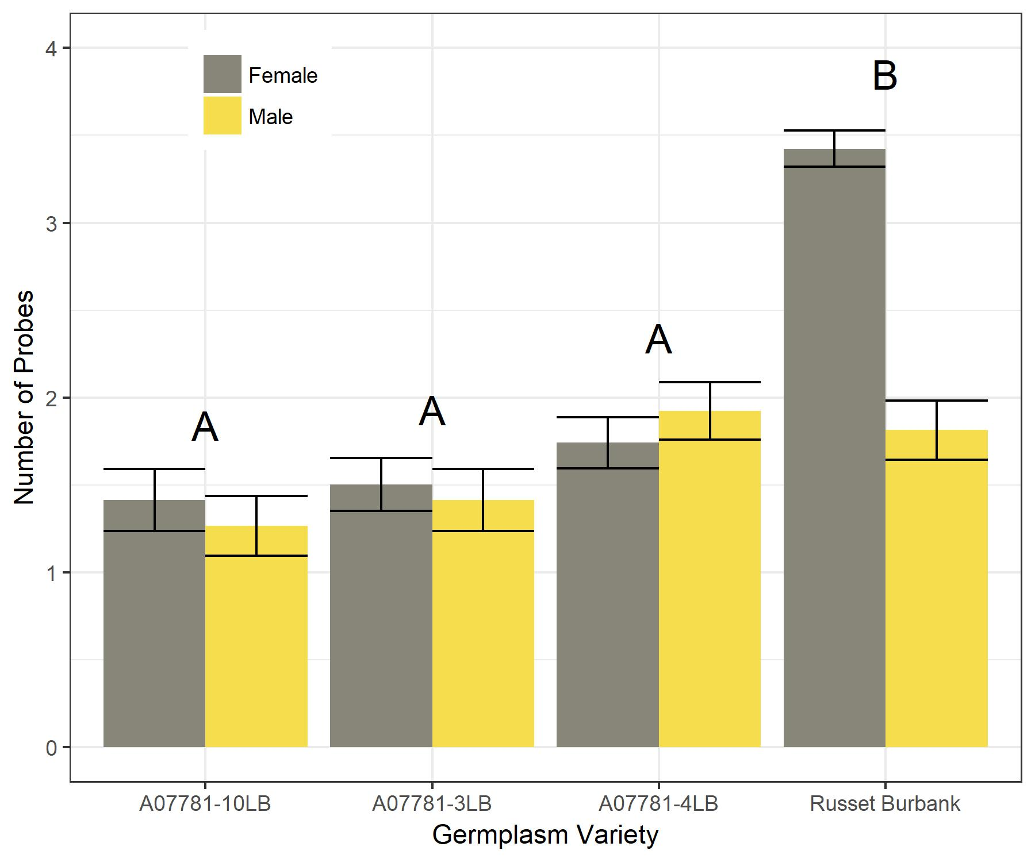

Figure 3.1: Mean (±SEM) feeding/probing counts recorded of psyllids feeding on different

germplasms during 300 seconds. Means which share a letter are not significantly

different (P > 0.05) and indicate differences by germplasm.

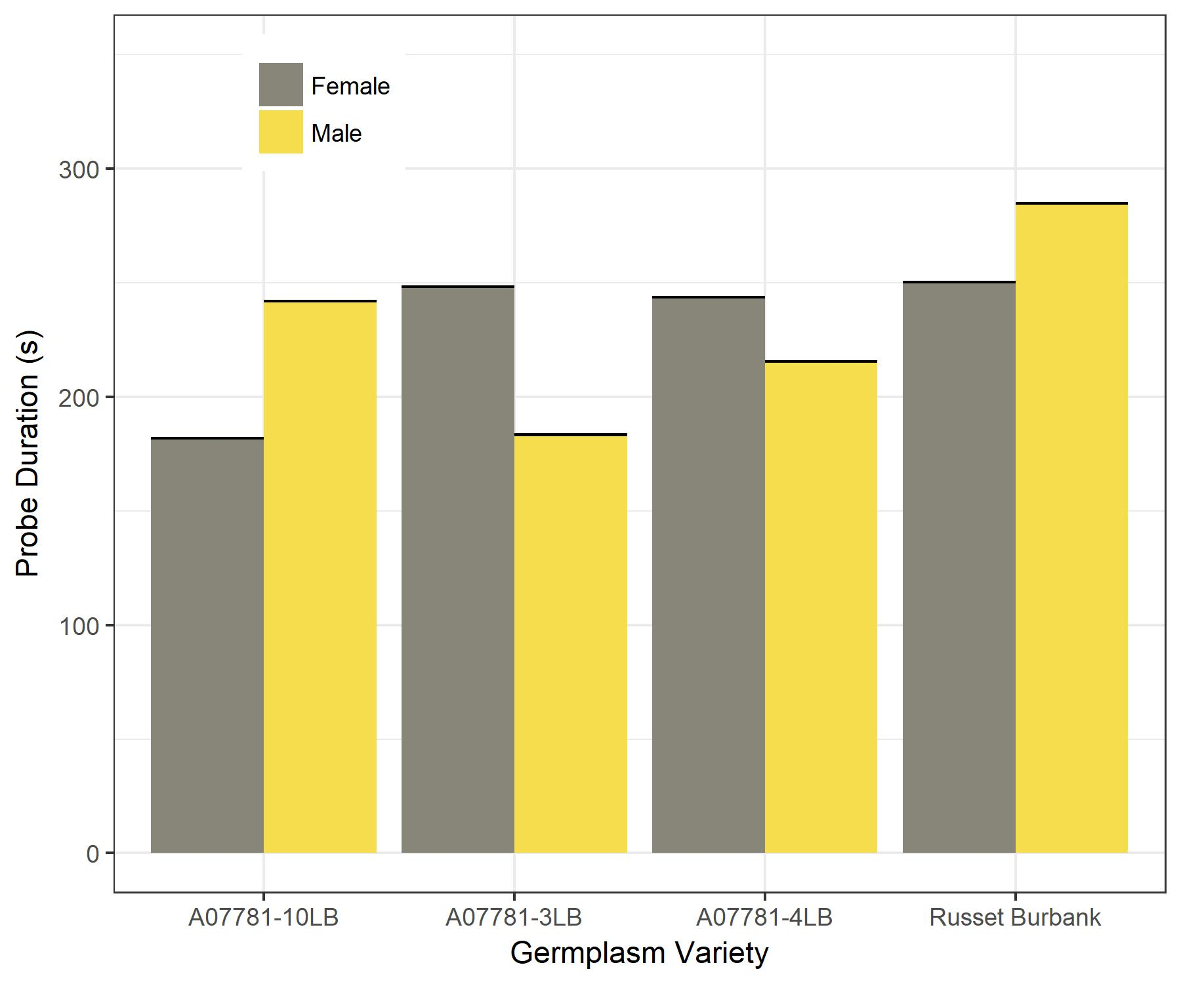

Figure 3.2: Mean (±SEM) feeding/probing duration of psyllids feeding on different

germplasms during 300 seconds. Means which share a letter are not significantly different

(P > 0.05).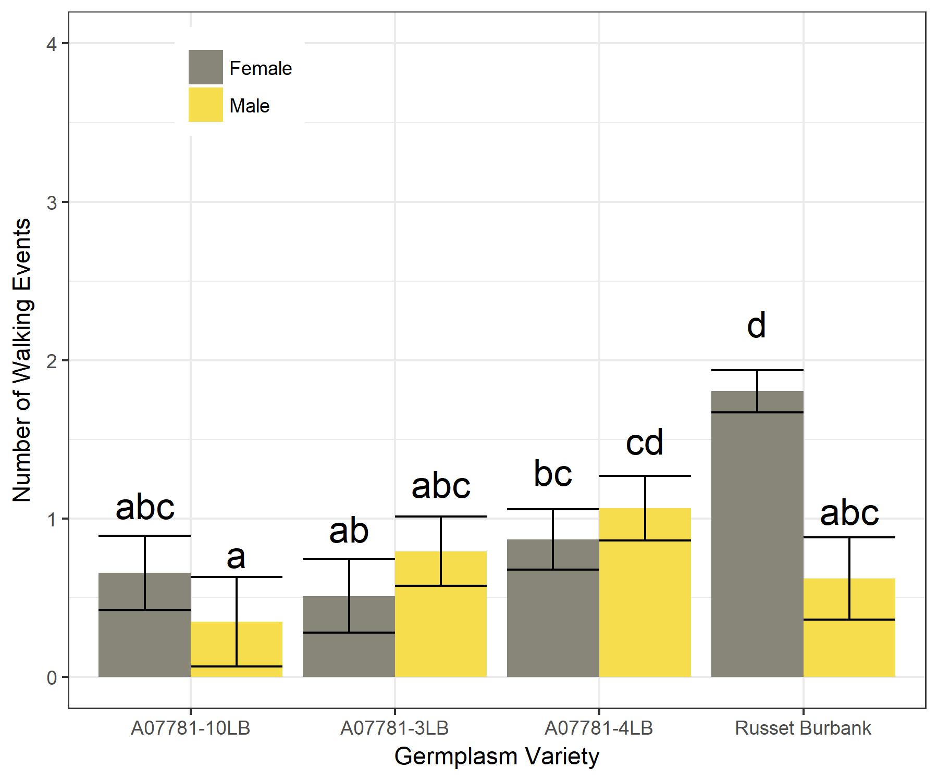

Figure 3.3: Mean (±SEM) walking counts recorded of psyllids feeding on different

germplasms during 300 seconds. Means which share a letter are not significantly different

(P > 0.05), indicate interactions between sex and germplasm.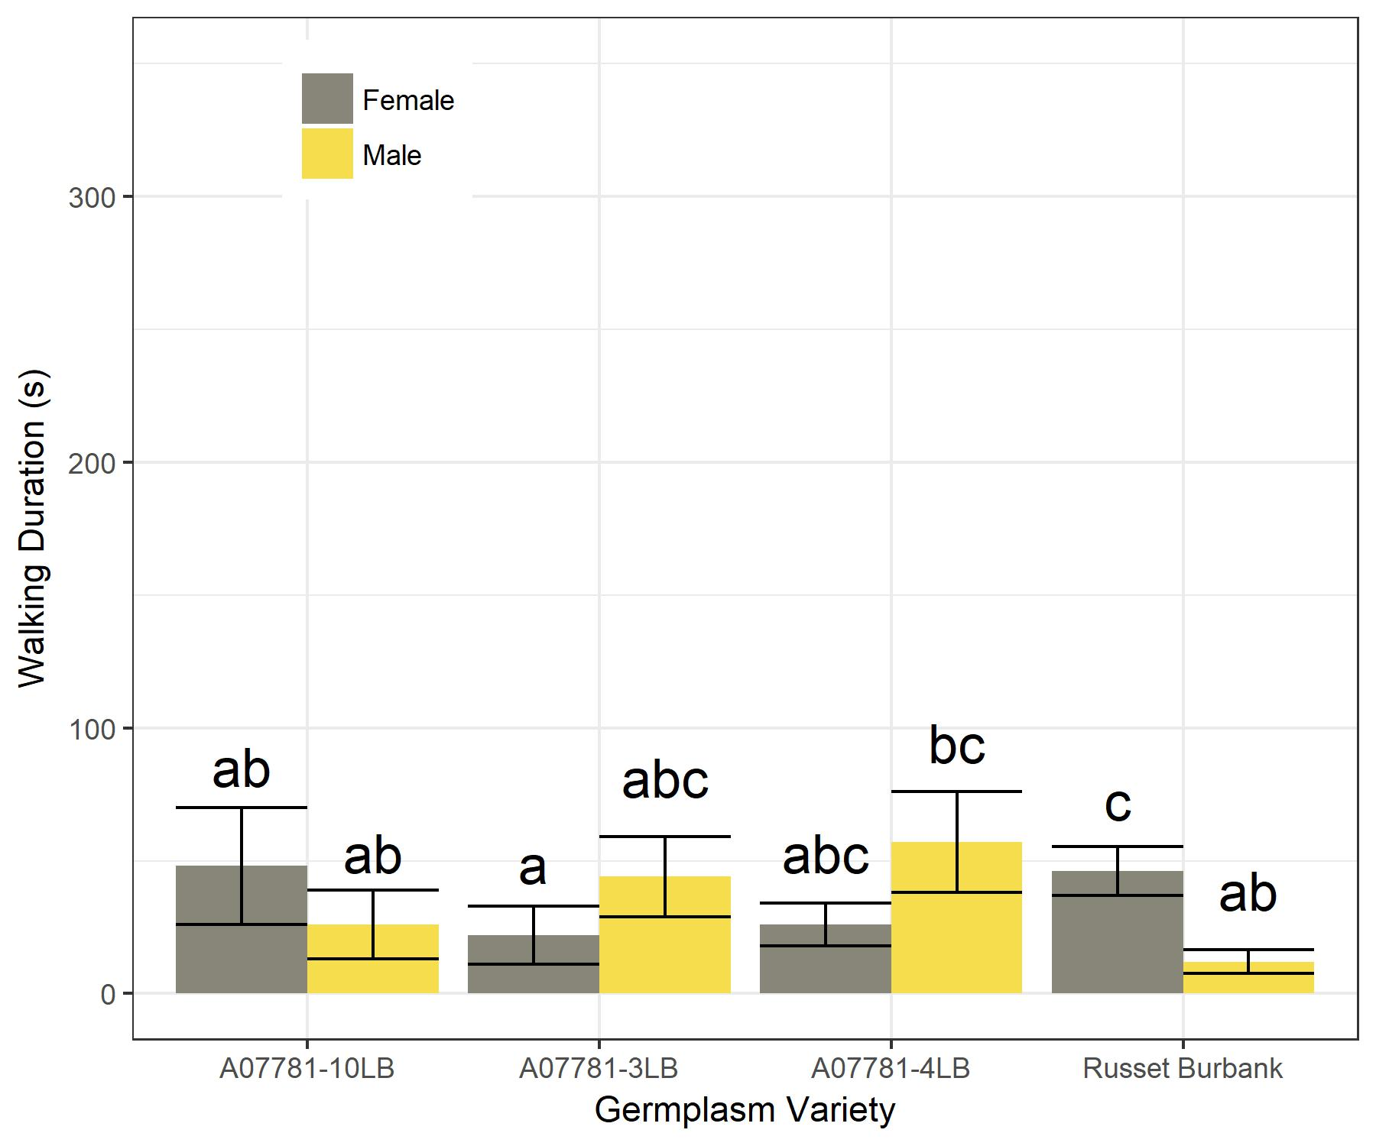

Figure 3.4: Mean (± SEM) walking duration of psyllids feeding on different germplasms

during 300 seconds. Means which share a letter are not significantly different (P >

0.05) and indicate differences by germplasm.